A Portrait of the Artist as a Young Man
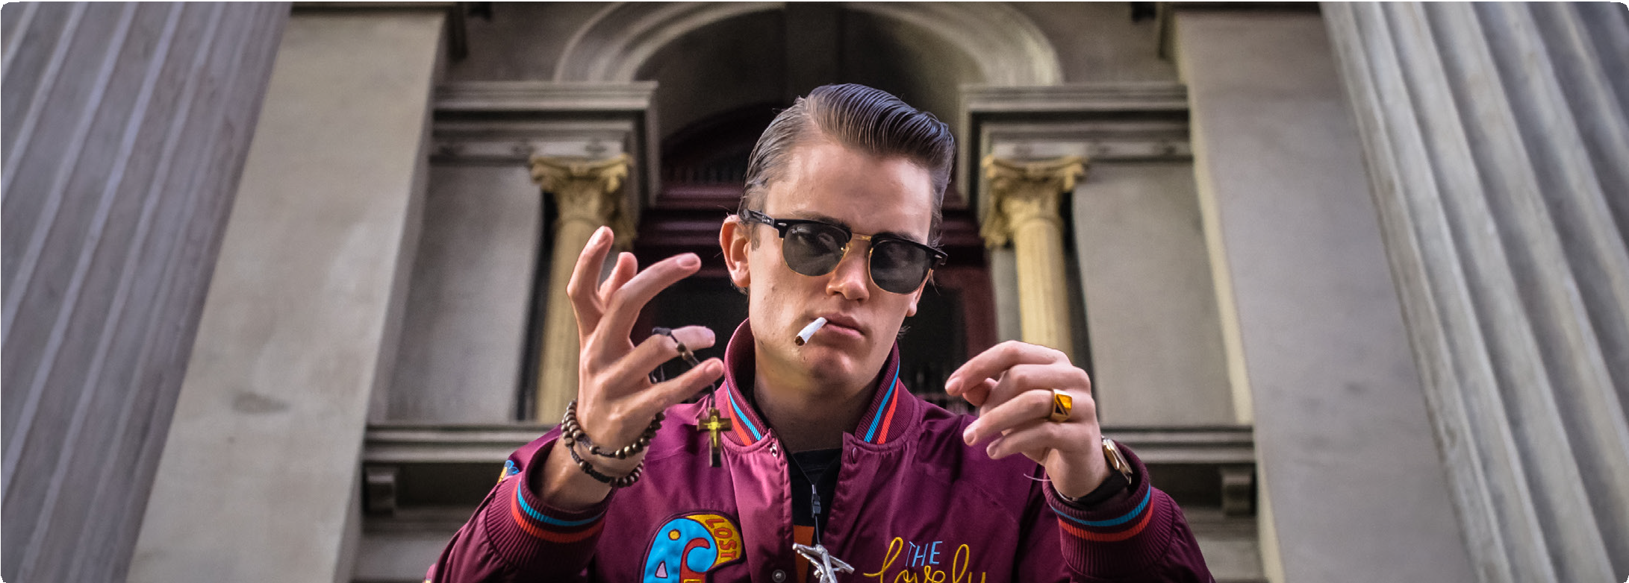

Rebel without a Pause

Presented by Bloomsday in Melbourne Directed by Wayne Pearn
15-19 June 2016

To mark the centenary of its publication in 1916, Blooms- day in Melbourne (now in its 23rd year and with 25 origi- nal Joyce-inspired plays under its belt), celebrates James Joyce’s most popular and user-friendly fiction, A Portrait of the Artist as a Young Man. The centre-piece is an original theatrical adaptation (with cadenzas) of Portrait at fortyfivedownstairs - ‘Exotic, patriotic, chaotic, erotic and hypnotic’, according to director, Pearn.

Alongside the play and amplifying it, is the seminar at Papa Goose, with the opportunity to kick back with the Bloomsday community for a two-course dinner.
Joyce was only 22 when he began Portrait, and it took him even longer to compose this short and compelling work than it did to create the masterpiece that is Ulysses.
His first attempt was hurled into the fire, and his final version provoked epic battles with censors and publish- ers. The Joyce who wrote about his past self was both intimate with, and comically critical of, the process of the artist-hero’s emancipation– from family, church, na-
tion, his own language, and the literary tradition he inher- ited. Matt Dorning is Stephen Dedalus, a rebel without a pause, a rebel with a cause – coltish, edgy, challenging, full of Sturm und Drang, and very funny. Can Stephen realize his exhilarating (over-reaching?) ambition to fly free, and make the world a-fresh, to live in a different relationship to his body, his society, knowledge itself, and his art?

Bookings essential: 03 9898 2900 http://www.bloomsdayinmelbourne.org.au/bookings

More Information: www.bloomsdayinmelbourne.org.au/ bloomsday-2016-a-portrait-of-the-artist-as-a-young-man/

Enquiries: Frances Devlin-Glass 0419 004 762

Event | When | Where | Tickets
Play: A Portrait of the Artist as a Young Man Directed by  Wayne Pearn | Preview, Wed. 15 June, 8.00pm Opening, Thurs. 16 June, 8.00pm Fri. 17 June, 8.00pm  Sat. 18 June, 8.00pm  Sun. 19 June, Matinee, 3.00pm | fortyfivedownstairs, 45 Flinders Lane, Melbourne | Earlybird (on some seats  – not 16 June): $33 Adult: $38  Concession: $33 (health & student cards)
Bloomsday Seminar | Thurs. 16 June, 3.30–5.15pm. | Papa Goose  91-3 Flinders Lane, Mel- bourne | $20  $15 Concession  (health & student cards)
Bloomsday Dinner and Entertainment | Thurs. 16 June, 6.00pm – 7.45pm | Papa Goose  91-3 Flinders Lane, Mel- bourne | $45  2-course meal; drinks at Bar Prices
